Graduate Student Organization
Spring 2025 General Meeting 1 Friday, Feb. 07, 2025, at 12:30 P.M.
Location: Bayou Room 211 - Student Union

- Call Meeting to Order: 12:33 P.M.
- Attendance [establish quorum: 50% +1 of current membership]
- President’s Welcome: Clement Tochukwu Okolo
- President’s Report: Clement Tochukwu Okolo
  - State of the Organization Address – [See Fall 2024 Advocacy Report]
    - GSO has a 90% department representation percentage, the highest since the 2022-2023 academic year.
    - The GSO has expanded the list of eligible exams for GSO funding.
  - Graduate Student Appreciation Week: April 6-11
    - Scavenger Hunt – tentatively Monday, April 7th
    - GSO Reps – Donut and Games with SGA and Graduate School
      - Reps will be assisting with bringing donuts to their respective departments, and will help on April 7th with games for GSA Week.
- Vice President’s Report: Abdel Garbie
  - Advocacy Committee Updates
    - Currently in talks with Graduate School for the Student-Faculty Relationship Town Hall.
    - In terms of what the GSO can do for graduate students who report power based violence, best practice is to send them to the appropriate office (Title IX for Power Based Violence, SA, and etc.; Graduate School for incidents related to Graduate Studies on a non-departmental basis)
- Treasurer’s Report: Farooq A. Khanzada
  - Status of current applications [see budget spreadsheet]
  - Update on Tier List, GSO Fee Increase – Call for Volunteers
    - See Ad-Hoc committee later in minutes.
  - Fund Raising Initiatives-- Restaurant Fundraiser, Bake and Sale
    - GSO Exec is meeting to discuss a giveback night at a restaurant, where a certain percentage of sales that mention GSO will be given back to GSO.
- Communications Report: Tessa Rock
  - Communications Committee Updates
    - Stay up and write will be scheduled three times this semester, with the first being 2/19/25.
    - Tessa is currently in contact with the T-Shirt manufacturer to come up with a plan to print and sell the shirts.

- Old Business
  - Student-Faculty Relationship Town-Hall Update
    - The Graduate School is currently planning for HR and Title IX to meet with GSO to assist in Student-Faculty relations.
- New Business
  - Vote—Funding Applications [see budget spreadsheet]
    - All funding applications that were adequate were approved for this funding meeting.
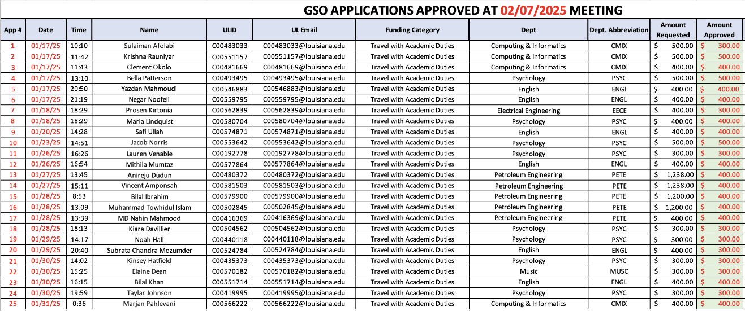

  - Vote—Formation of Ad-Hoc committee [if necessary]
    - The formation of an Ad-Hoc Task Force to assist in drafting a GSO fee increase proposal and research a new tier system based on Louisiana’s per diem rates was approved.
- Other Advocacy/Concerns/Questions
  - Question to the Dean: What is the status of federal grants and funding?
    - Response: The recent executive order to put a pause on Federal funding has since been rescinded. However, it is anticipated that there may be future incoming grants and funding that may be withheld. As of now, the position of the School is to await further instruction.
- Announcements
  - After this meeting, the GSO President will follow up via email to reps with notes you can relay to your departments’ students
  - Representatives are responsible for finding a successor and ensuring that they understand their responsibilities [see By-law]
- Adjournment: Meeting adjourned at 1:47 P.M.

